# Adding a User using the Program

## To Start - Background

* This document will show you how you can add a user and their access code to the database.
* Team 1 has an admin user. You must login as that admin user in order to access hunt functionality.

### Steps

1. Run the program. You should be taken to this screen:

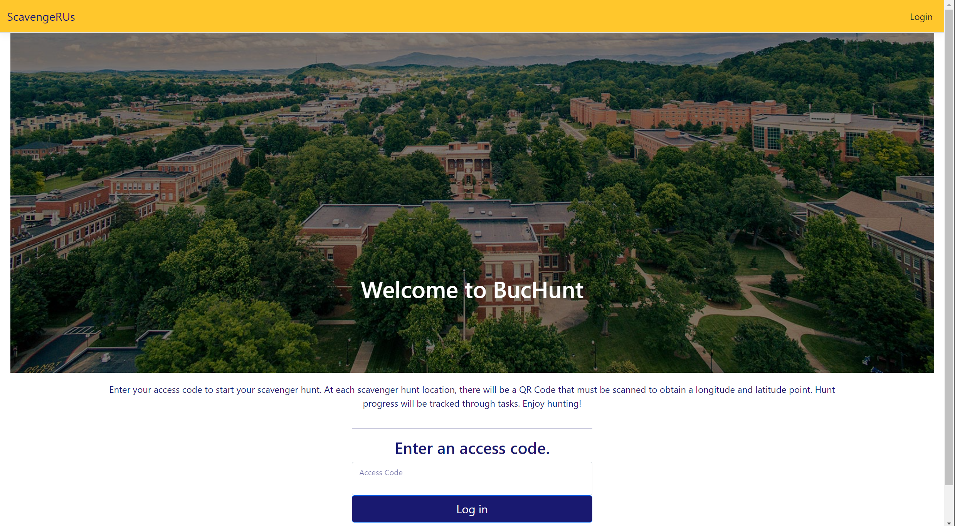

1. You probably start off logged in as a test user. On the top-right of the screen, click “Log Out”.
2. Then click “Login” after you’ve logged out. You should be taken to this screen:

1. The admin of this project’s credentials are:
   1. Email: [waltonca@etsu.edu](mailto:waltonca@etsu.edu)
   2. Password: YMXH@9J!72kM6Em
2. Press the “Log in” button after you enter the credentials above. You should be taken back to the BucHunt landing page:



1. Click on “Admin Portal” (highlighted in red above). You should be taken to the screen below:

1. If you are wanting to create an **ADMIN, click Create New User**. However, don’t do this when adding a new user – there is a better way. If you want to create a **USER, click Manage Hunts/Tasks**

### Making an(other) Admin

1. Enter the Email, First Name, Last Name, and Phone Number of the person you want to add as an admin.
2. Select the “Admin” Role. By now, your website should look similar to this:

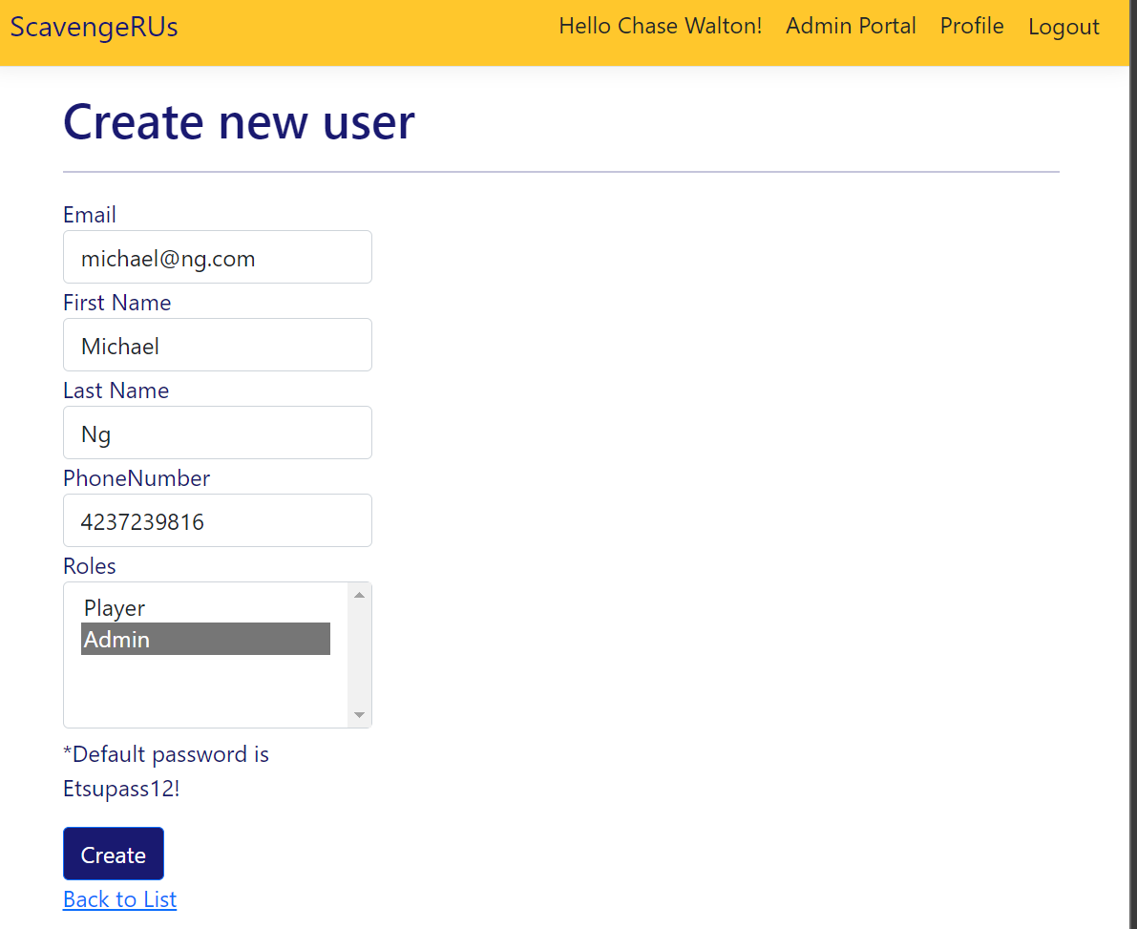

1. You will be taken to a details page. It looks like this:

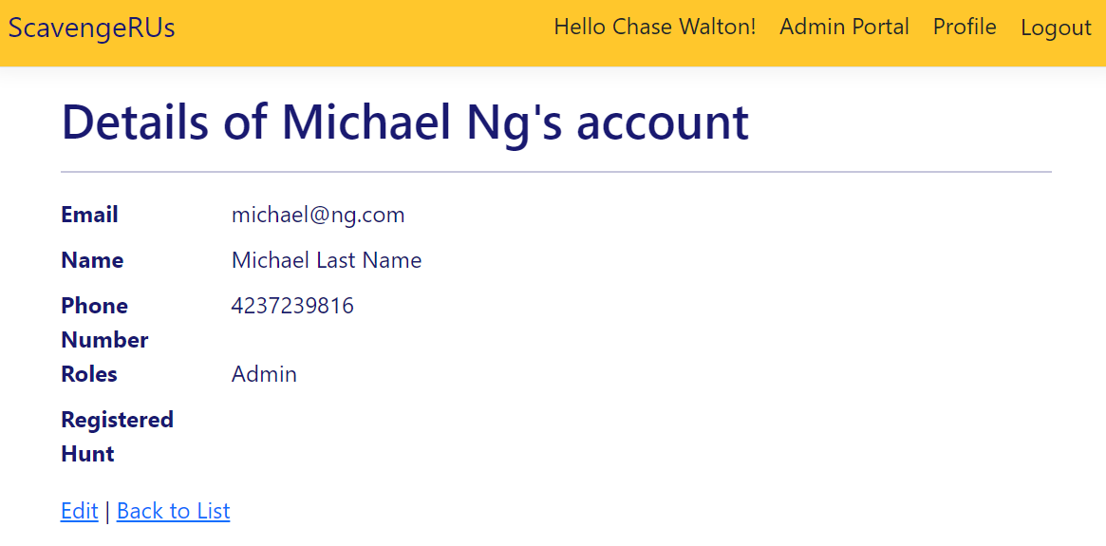

### Making Another User